NETWOEK TROUBLESHOOTING MANAGEMENT

Q1. Use the Windows command prompt to run the command ipconfig /all on your computer and take a screenshot of the output. Identify and write down your IPv4 address, subnet mask, default gateway, and DNS servers as shown in the result.
Ans.
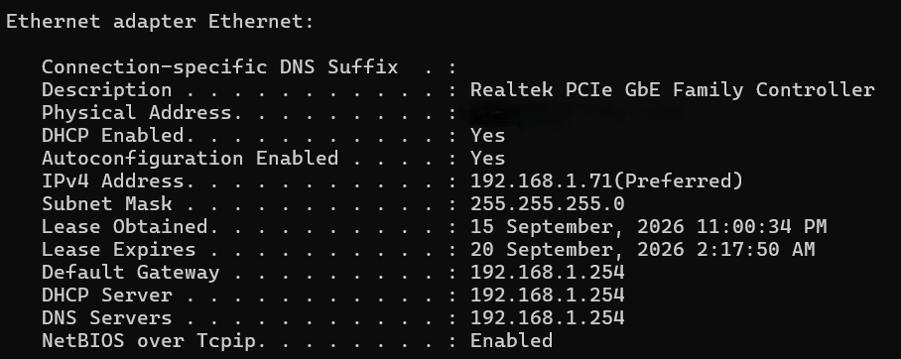
Q2. Simulate a network connectivity issue by disconnecting your Wi-Fi or Ethernet cable, then use the ping command to check connectivity to www.google.com. Reconnect and repeat the ping. Write a short note on the difference in results and what each status means.
Ans.
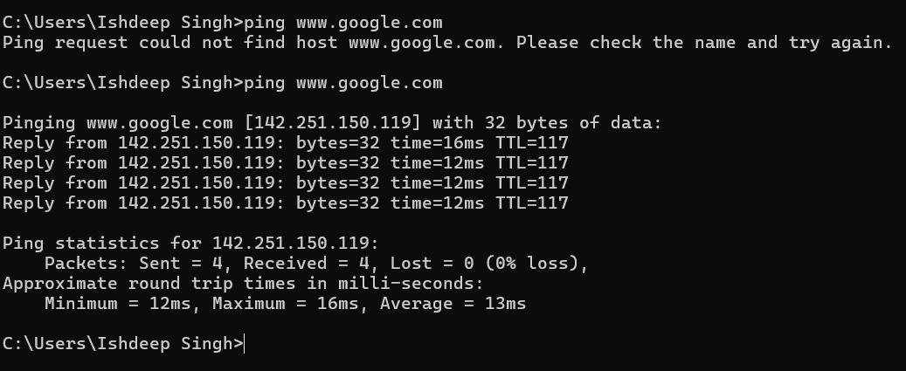
- When the pc was not connected to a network the ping command output was Ping request could not find host www.google.com. And when I have connected the pc to internet work it started getting reply from www.google.com

Q3. Open Task Manager or Resource Monitor on your system and monitor network usage for 5 minutes while streaming a YouTube video. Record the peak network usage value and note which process used the most bandwidth during this time.
Ans.
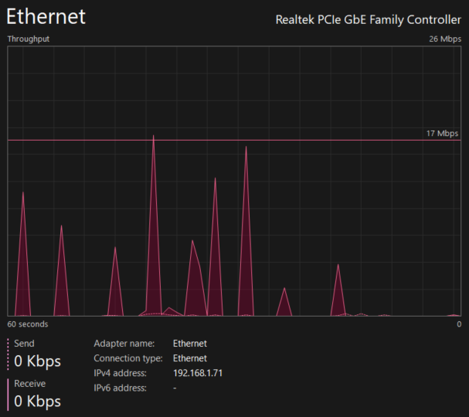
- This is the SS of my internet usage during I was watching a YouTube video
Q4. Download and install Wireshark (or use an online packet capture demo if installation is not possible). Capture at least 30 seconds of network traffic while browsing Flipkart or Instagram Web, then filter the packets to show only HTTP or HTTPS traffic. List 3 types of information you can see in these filtered packets. Hint: Use the filter bar in Wireshark and try http or https as the filter keyword.
Ans. 3 Types of Information Visible
Information | Example from SS
Source IP Address | 192.168.1.71
Destination IP Address | Examples include 104.18.4.159, 172.217.116.4, and 162.247.241.14
Protocol And Port | TLSc1.2, TLSv1.3, and QUIC; HTTPS traffic commonly uses port 443

Q5. Imagine your friend is complaining about slow internet while gaming online. Use ChatGPT or any AI tool to generate a troubleshooting checklist (at least 5 points) for optimizing home network speed and reliability. Paste the AI's response and highlight one suggestion you would try first.
Ans. AI-Generated Troubleshooting Checklist
- Use an Ethernet cable instead of Wi-Fi if possible for a more stable gaming connection.
- Restart the router and modem to clear temporary network problems.
- Move closer to the Wi-Fi router or place the router in an open, central location.
- Reduce other network usage by pausing downloads, streaming, or large uploads while gaming.
- Check for router and device updates and install available firmware/network-driver updates.
- Use the 5 GHz or 6 GHz Wi-Fi band when supported and when the device is reasonably close to the router.
- Check ping/latency with a command such as ping to determine whether the problem is network delay rather than download speed.
Suggestion I would try first
- I would try using an Ethernet cable first, because a wired connection usually provides lower and more consistent latency than Wi-Fi, which is especially useful for online gaming.

